Nisarg Bansinge
Salesforce Developer
✉️ nisargabansinge@gmail.com
📞+919022220973
Career Objective :
Completed a 6-month Salesforce Training/Internship at Cloud Intellect, where I gained hands-on experience in software development, CRM workflows, and application customization. I'm now ready to advance in Salesforce Development, seeking a role to further enhance my skills, contribute innovative solutions, and collaborate effectively for mutual success.

- Analyzed client requirements and completed tasks within set deadlines.
- Implemented Flow, Validation Rules, Process Builder, and Sharing Rules to meet business needs.
- Managed data migrations across Salesforce Orgs using the Import/Export Wizard and Data Loader.
- Developed dashboards, reports, and custom report types according to client specifications.
- Gained Experience with Lightning Components, Lightning Events, Apex Classes, Apex Triggers, and Apex Test Classes.
- Learned to implement Batch Classes and Scheduled Classes based on business requirements.
- Acquired hands-on experience with Salesforce Lightning and App Builder, and practiced writing queries using SOQL and SOSL in Apex Classes and Triggers.
- Became familiar with various Salesforce deployment methodologies, including Change Sets and VS Code.
- Assisted in troubleshooting and resolving issues related to Salesforce configurations and customizations, ensuring smooth project delivery.
- Contributed to the optimization of Salesforce performance by refining code and improving Flows.
- Participated in regular code reviews and collaborated with senior developers to ensure best practice and high-quality deliverables.

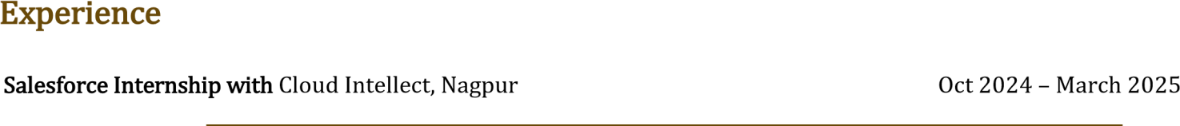
- Managed user accounts, roles, profiles, and permission sets; performed data imports, exports, and updates using Data Loader and Workbench, ensuring data integrity.
- Configured security settings, including sharing rules, OWD, and field-level security; assisted with sandbox setup for testing and development.
- Developed Apex classes, triggers, and batch jobs to implement business logic and automate processes; integrated Salesforce with external systems using REST and SOAP APIs.
- Created and executed test classes for code coverage and quality; debugged issues in Apex code; ensured adherence to Salesforce best practices, and assisted in deploying customizations from sandbox to production.
- Built responsive interfaces with Lightning Web Components (LWC); customized LWC components and implemented two-way data binding with Apex controllers.
- Managed component communication via custom events; optimized LWC components for performance; maintained documentation of configurations and customizations; collaborated with senior developers and stakeholders to deliver aligned solutions.

- Salesforce Sales/Service Cloud
- Validation Rule, Security Model, Automation Tools
- SOQL,SOSL, Apex Trigger, Test Classes, Asynchronous Apex

- LWC, JavaScript, HTML
- Data Loader
- Visual Force
- Integration with REST/SOAP

B.C.A. Kamla Neharu Collage Nagpur 2021-2024 64.3%
H.S.C. Jawahar Junior Collage Khapa(Nagpur) 2020-2021 74.6%
S.S.C. Jawahar High School Khapa(Nagpur) 2018-2019 65.6%

Personal Details

Full Name : Nisarg Tejraj Bansinge
Date Of Birth : 29th June 2004
Marital Status : Unmarried
Gender : Male
Language Known : English, Hindi, Marathi.
Address : At.Kochchhi, Tah.Saoner, Dist.Nagpur, Maharashtra Pin Code- 441101

